The facts are these: The Electronic Patient Records for Primary Health Care is being implemented at the Health Centres and which platform will also be extended for use to Private practices

This will be a two-way process: Doctors will access patient data (more about this below), but a subset of their data that is essential for continuity of care will also be made accessible to others through the separate National Electronic Health Records, should the doctor accepts to use the EPR platform offered by Government. Doctors who opt not to use it will still be legally obliged to insert the continuity-of-care data into the National Electronic Health Records.

Thus, using this system means that the Family Doctor becomes a joint data controller in the eyes of the legislation, and although each doctor is responsible to record quality and timely data, the doctor is not the sole entity responsible. We should also be aware that patient data is actually owned by the patient, and not by the creating organisation or professional. The new EPR system is aligned with the principles of Data Privacy, hence safeguarding professionals utilising it, by ascertaining such principles and control.

If a Family Doctor has no electronic patient record system or it is felt it is not good enough, especially in view of the GDPR obligations in relation to sensitive data, it is possible to be given access to the PHC electronic patient record platform and start afresh.

Then there are the National Electronic Health Records

This is being implemented by Government at the national level, involving all public and private healthcare providers. It will consolidate information from various sources as per high level diagram below, extracted from Project tender.

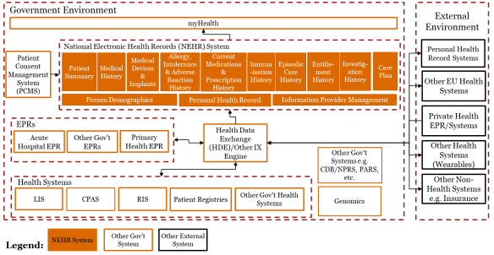

Once a doctor agrees to use the Electronic Patient Record for Primary Care, which system, will automatically be connected to these National Electronic Health Records, records will traverse from EPR to NEHR automatically in a controlled manner, based on the patient one is accessing, whilst if private practices utilise their own system, the connectivity with the National Electronic Health Record will need to be setup by the respective practice.

